7-2 Project Two Submission README
Lacey Mikolon
Southern New Hampshire University
CS-340-12599-M01
Professor Gebre-Amlak
December 13th, 2025

Grazioso Salvare Animal Rescue Dashboard
Author: Lacey
Course: CS-340
Project: Project Two – Dashboard

Project Functionality and Proof of Completion
The Grazioso Salvare Animal Rescue Dashboard was developed to provide an interactive tool for identifying dogs suitable for specialized rescue operations using the Austin Animal Center Outcomes dataset. The dashboard allows users to filter animals by rescue type, including Water Rescue, Mountain or Wilderness Rescue, and Disaster or Individual Tracking. A reset option is also included to return the dashboard to its original, unfiltered state. The interface contains interactive filter controls, a dynamic data table, a geolocation map, and a secondary chart that visualizes breed distribution. The Grazioso Salvare logo and a unique identifier (“Dashboard by Lacey”) are displayed on the dashboard to meet branding and identification requirements.
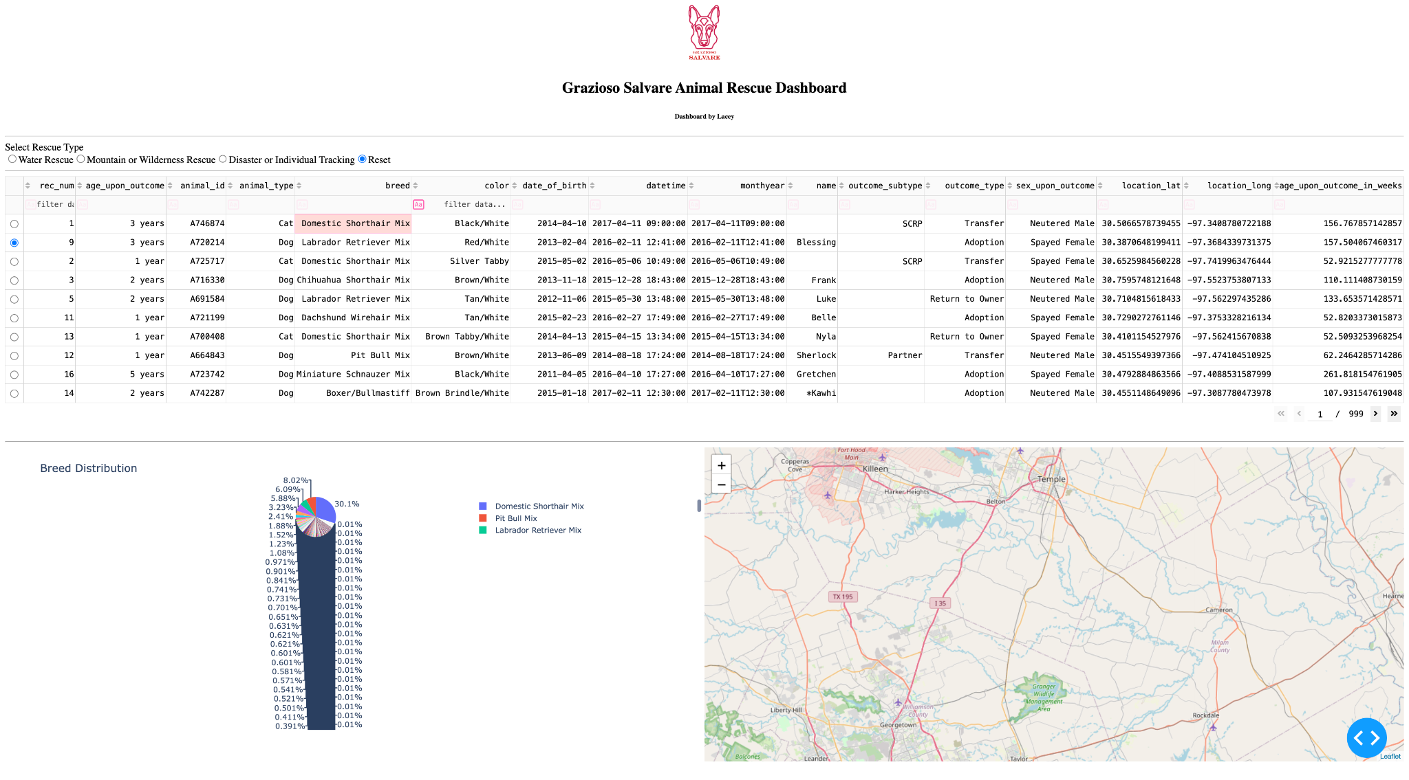
When the Water Rescue filter is selected, the dashboard updates dynamically to display only animals that meet the Water Rescue criteria. The data table refreshes to show only relevant records, the breed distribution chart updates to reflect the filtered data, and the geolocation map displays the location of the selected animal. This demonstrates that the interactive controls correctly retrieve and display filtered data from the database.
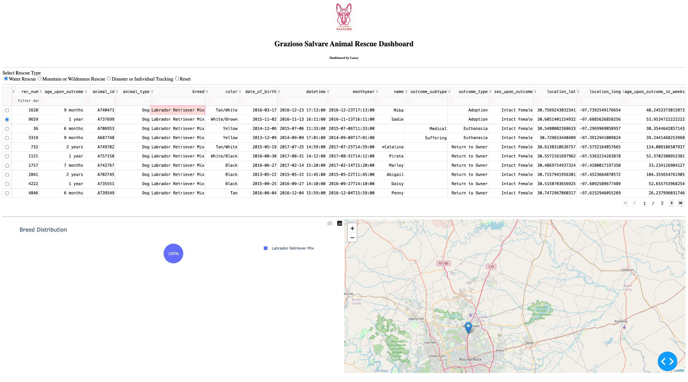
Selecting the Mountain or Wilderness Rescue filter updates the dashboard to display dogs suitable for mountainous or wilderness environments. The data table, breed distribution chart, and geolocation map all update automatically based on the selected filter, confirming that the dashboard responds correctly to user input and applies the appropriate MongoDB queries.
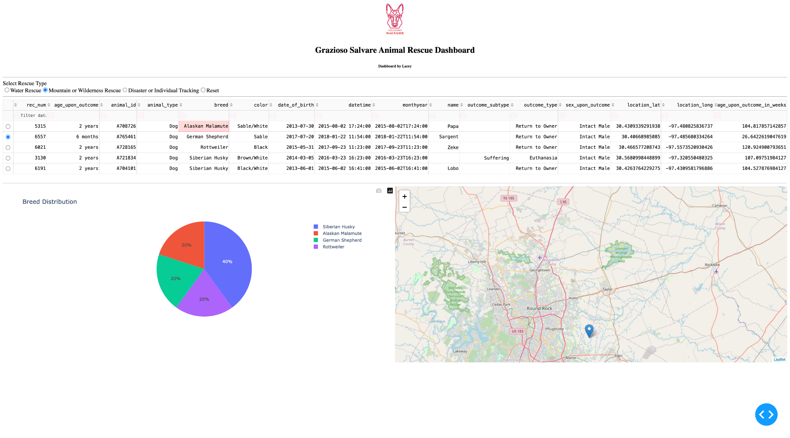
The Disaster or Individual Tracking filter further demonstrates the dashboard’s functionality by limiting results to dogs appropriate for disaster response or tracking operations. As with the other filters, the data table and both charts update dynamically, providing visual confirmation that the filter logic and database queries are functioning correctly.
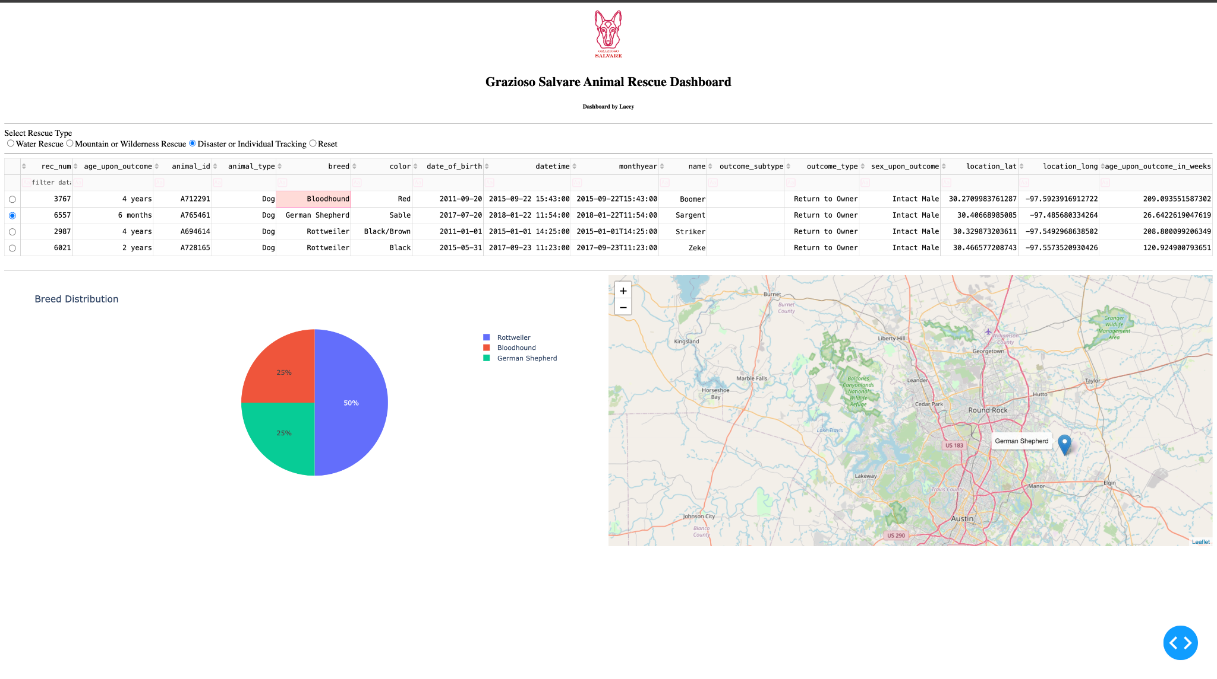
Finally, selecting the Reset option returns the dashboard to its original, unfiltered state. All animals are displayed again in the data table, and the charts revert to showing the full dataset. This confirms that users can easily return to the starting state without refreshing the application.
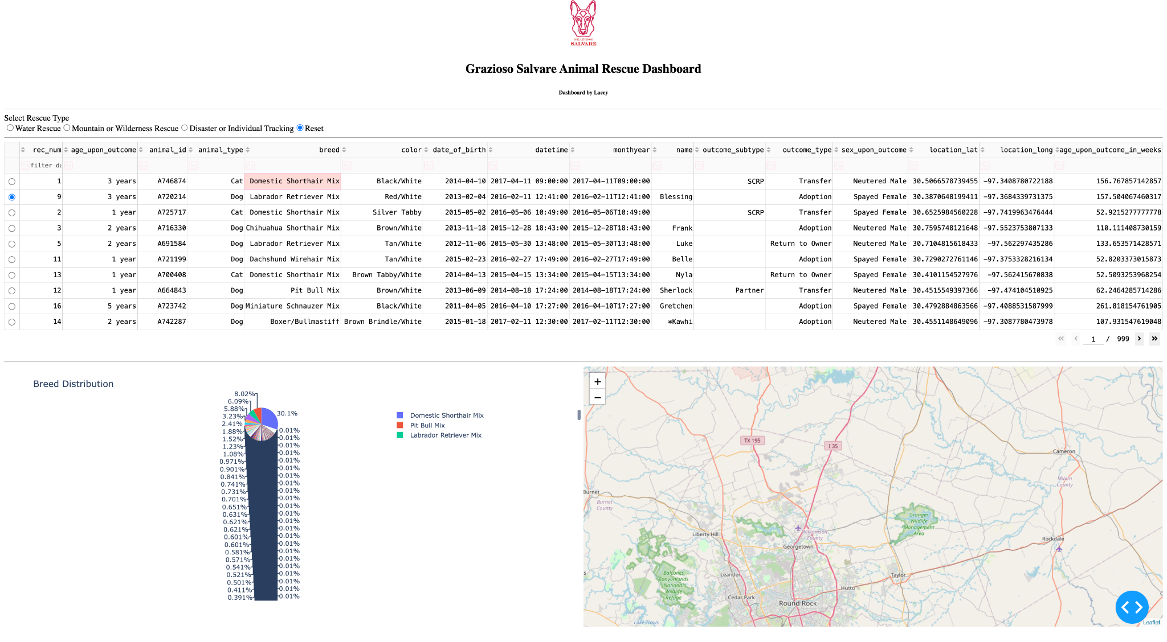

Tools Used and Rationale
Python was used as the primary programming language due to its strong support for data processing, database interaction, and web application development. MongoDB was selected as the database for storing and querying the Austin Animal Center Outcomes data, and PyMongo was used to connect to MongoDB from Python. The Dash framework was used to build the interactive dashboard because it allows developers to create responsive web applications using Python alone. Pandas was used to manipulate and structure the dataset after it was retrieved from the database; Plotly Express was used to generate the interactive breed distribution pie chart; and Dash Leaflet was used to implement the geolocation map. These tools were chosen because they integrate seamlessly and are well-suited for interactive, data-driven applications.

MongoDB as the Model Component
MongoDB was used as the model component of the application due to its document-oriented design and flexible schema. The Austin Animal Center dataset naturally fits MongoDB’s JSON-like document structure, which maps directly to Python dictionaries. This made it efficient to retrieve and manipulate data using PyMongo. MongoDB’s query operators, such as $in, $gte, and $lte, enabled the application to filter animals by breed, age, and sex based on rescue type requirements. MongoDB also supports fast data retrieval, which is essential for dynamically updating dashboard components in real time.

Dash Framework as View and Controller
The Dash framework provides both the view and controller layers of the dashboard application. The view is defined by the dashboard layout, which includes radio button filters, an interactive data table, a pie chart, a geolocation map, and branding elements. The controller logic is implemented through Dash callbacks, which respond to user interactions such as selecting a rescue type or choosing a row in the data table. These callbacks retrieve filtered data from MongoDB through the CRUD module and update the dashboard components accordingly, ensuring a responsive and intuitive user experience.

Development Process
The project was completed by first reviewing the Dashboard Specifications Document to understand all required features and design expectations. The CRUD Python module created in Project One was reused to connect to the MongoDB database and retrieve data. An unfiltered data table was created to display the full dataset as the initial dashboard state. MongoDB queries were then developed for each rescue type. Interactive filter controls were added using Dash radio buttons, and callbacks were implemented to connect these controls to the data table and charts. A geolocation map and breed distribution chart were added, followed by the inclusion of the Grazioso Salvare logo and unique identifier. The dashboard was then tested thoroughly, and screenshots were captured to document its functionality.

Challenges and Solutions
Several challenges were encountered during development. Initially, a mismatch between the CRUD module’s class name and the class referenced in the dashboard code caused runtime errors. This was resolved by correcting the import and class instantiation. Dash callback errors related to uninitialized data were addressed by adding guard conditions to handle empty or None values safely. Additionally, issues with loading the logo image due to filename spacing and case sensitivity were resolved by matching the file path exactly. Overcoming these challenges resulted in a stable and fully functional dashboard.

Conclusion
The Grazioso Salvare Animal Rescue Dashboard meets all project requirements and provides an effective, user-friendly interface for exploring rescue-ready animals. The dashboard integrates MongoDB as the model component and uses Dash to deliver a responsive web application. The included screenshots clearly demonstrate that all required functionality has been implemented and tested successfully.

